Amazon Certificate Manager

How to enable certificate for an application running on ec2 instance for secure connection (https)
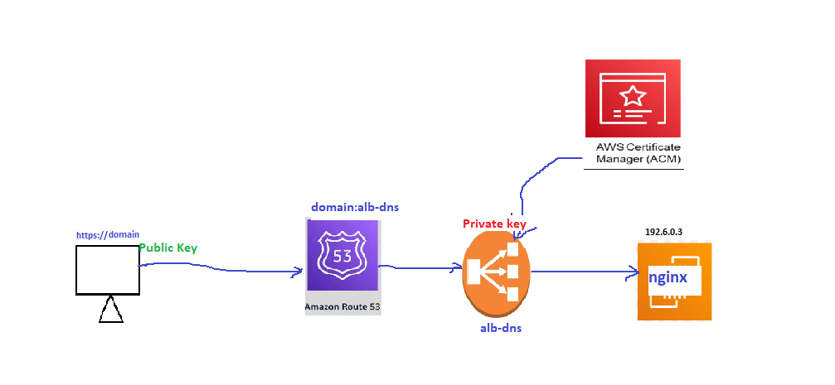

AWS ACM + ALB + EC2 — Correct Flow
- Create EC2 instance and install/configure Nginx. Then start the service
- Create/register your custom domain.
- Create a Public Hosted Zone in Route 53.
- Request an ACM Public Certificate for your domain.
- Choose DNS Validation and add the ACM validation CNAME to Route 53.
- Wait until ACM certificate status becomes Issued.
- Create an Application Load Balancer (ALB) — Internet-facing.
- Create a Target Group and register the EC2 instance on port 80.
- Create an HTTPS listener (443) on ALB and attach the ACM certificate.
- Configure ALB to forward HTTPS : 443 → HTTP : 80 → EC2/Nginx.
- In Route 53, create an A record → Alias → ALB.
- Access the application using:
https://yourdomain.com

Certificate manager>request certificate
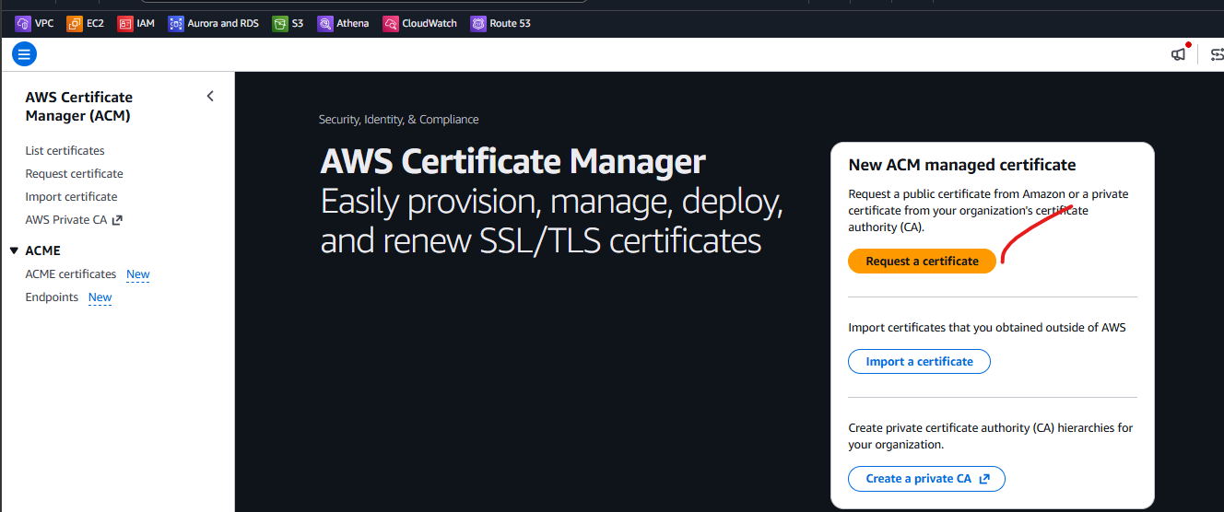

Give your domain name ,keep everything default and next
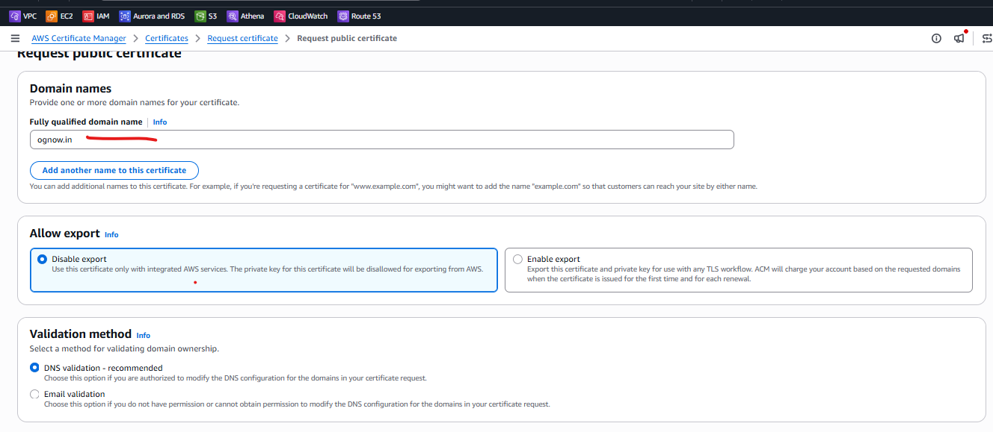

It will show like this
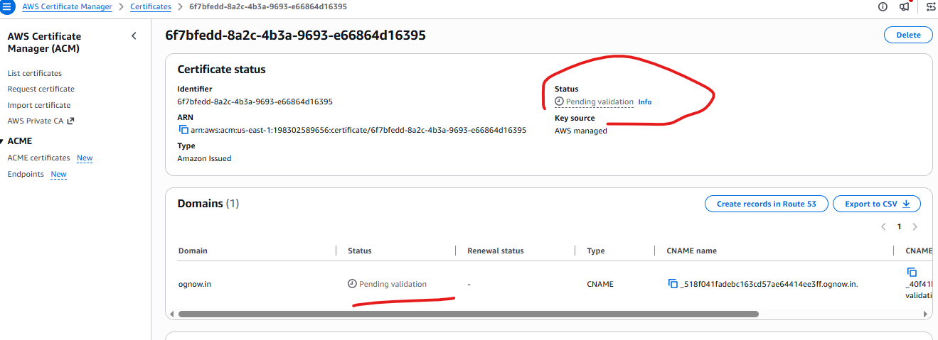

Update the nameservers in your domain nameservers.
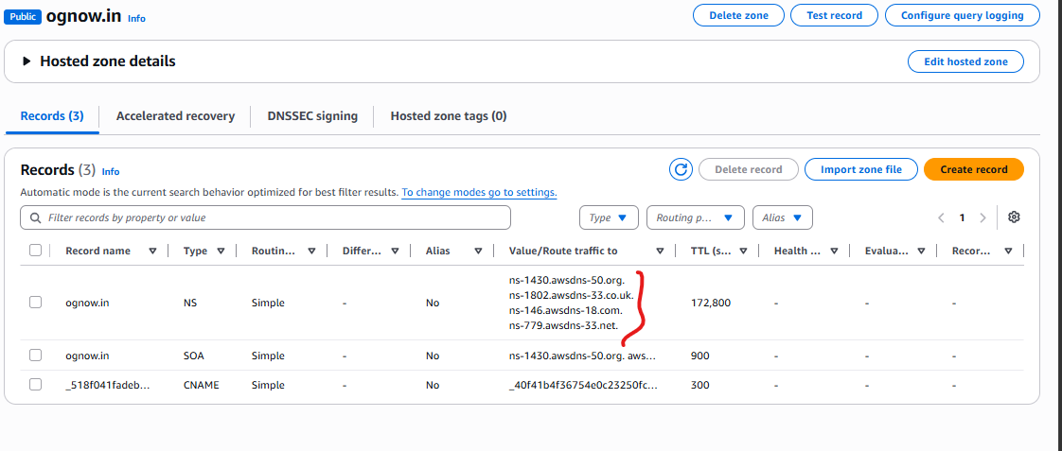
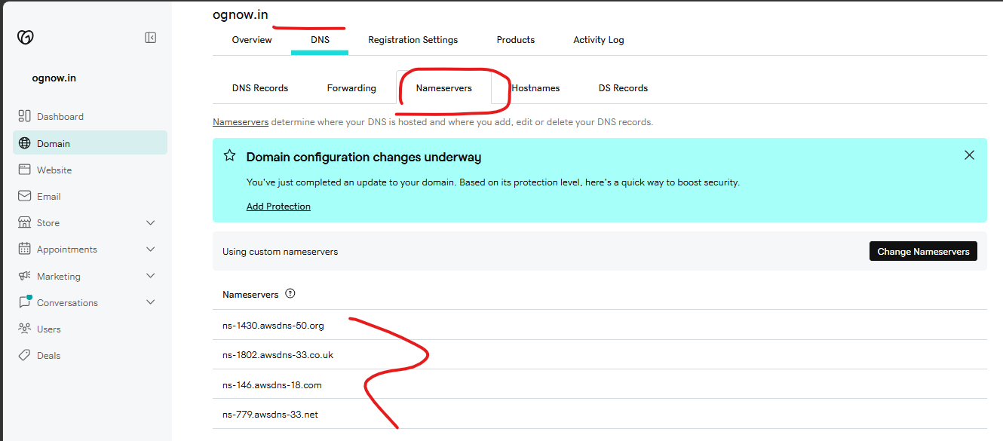
If you don’t update the nameservers then it will fail to validate.
Wait till the certificates issued
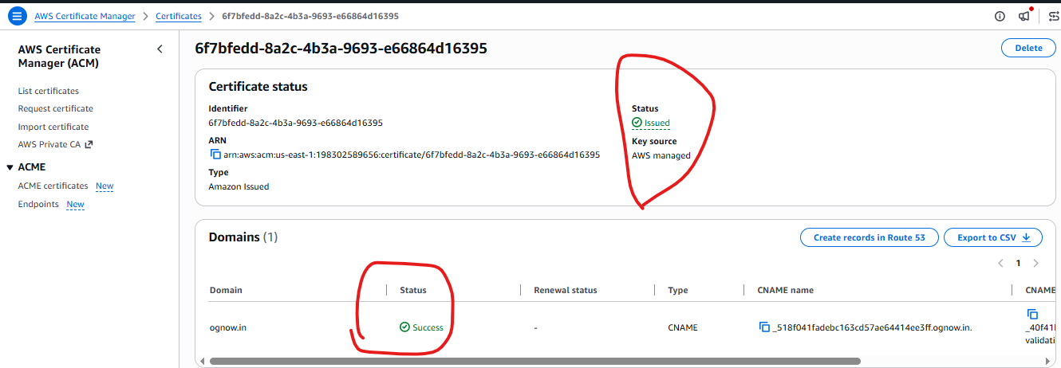

Set up ALB –
(ALB HTTPS : 443 → Target Group : HTTP : 80)
Create target group with the port:80 where nginx is running
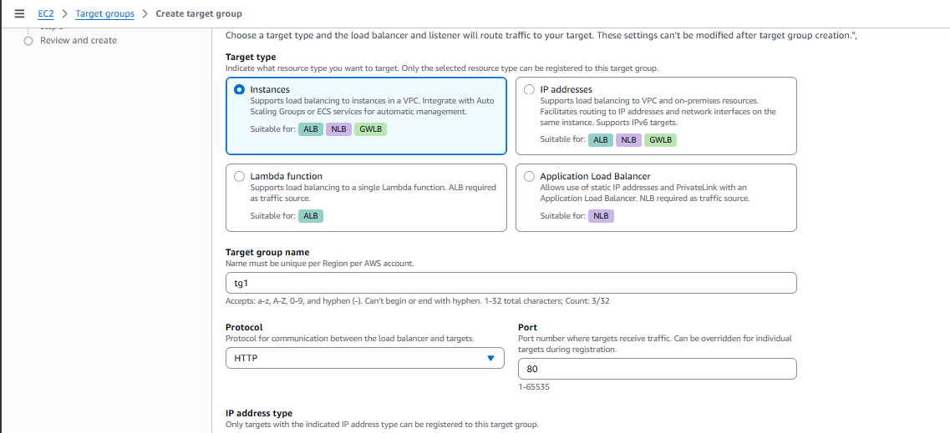

Create and attach Tg1 to ALB , observe we are selecting https(443)
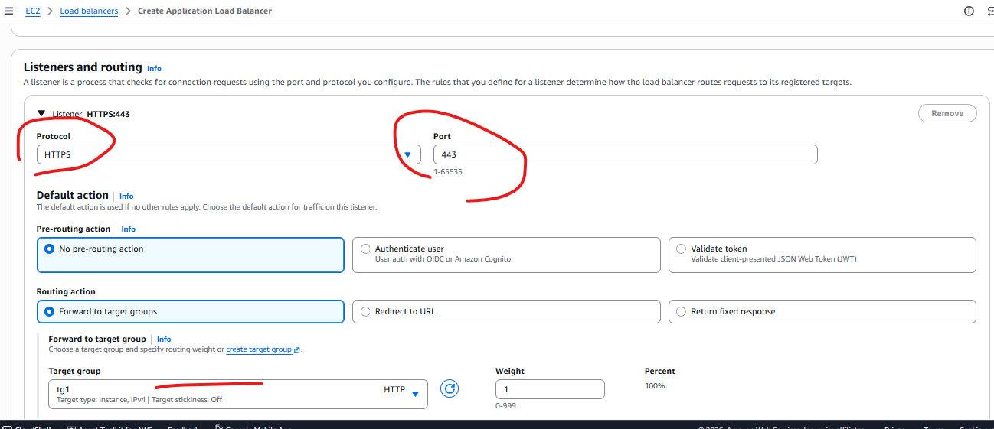

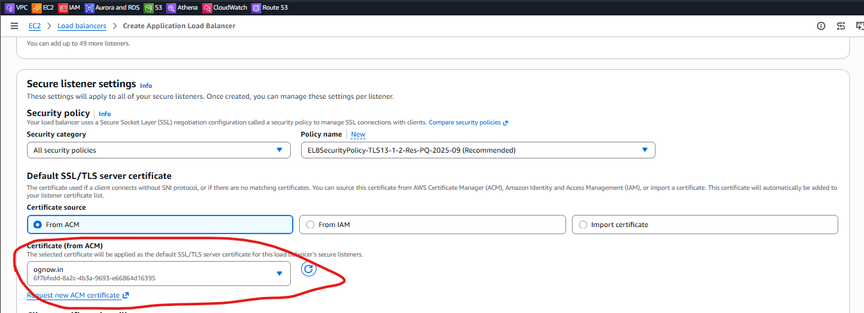

Then configure the domain and create .
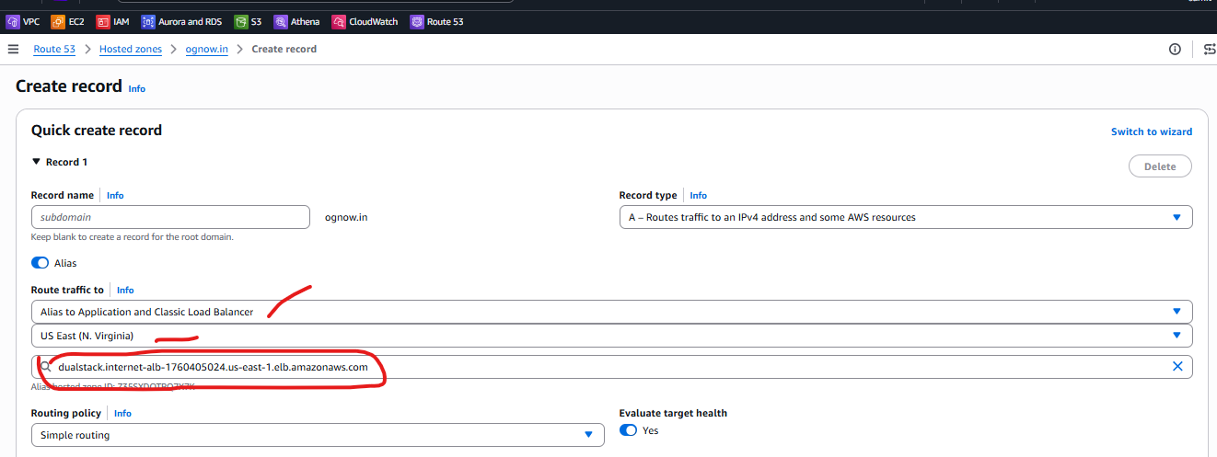
Final ongow.in should look like
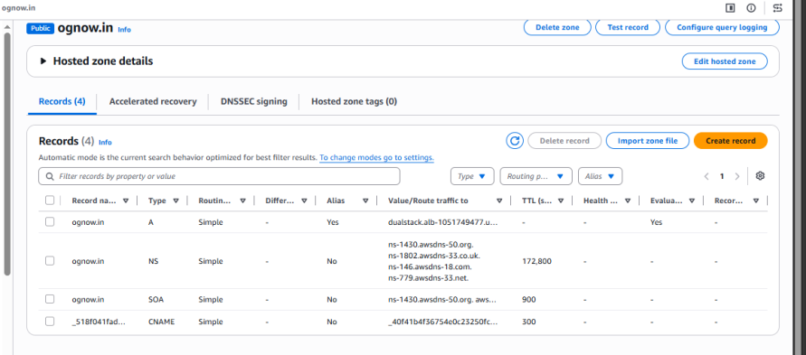

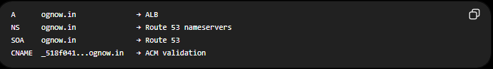

Then try access the web application,via domain enabling https protocol.
https://ognow.in
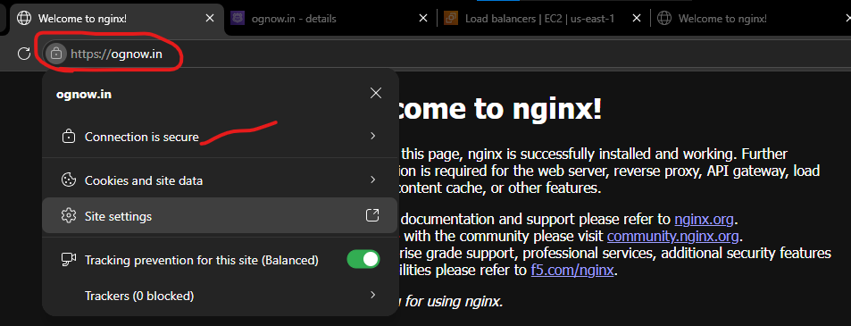
You can see the domain is secure by using https protocol .
Key point to remember –
Certificates generated in ACM (0ne private key and one private key)
Private certificate is attached to ALB not ec2 instance .
Public key shared to the browser for supporting the 3 way hand shaking

